CLIMATE SMART SEAPORTS - PACIFIC Developer Documentation
Online decision support toolkit for climate resilient seaports

RMIT University
Prepared by: Guillaume Prevost
Date: 12/05/2014
Document Version: 1.0

USAID Activity Number | CCRDACD0005
Project Title | Decision-support toolkit: towards Climate Smart Seaports in the Pacific Islands
Organisation responsible for the project | RMIT University
Name of Contact Person | Professor Darryn McEvoy
Address and contact details of Contact Person | Address: GPO Box 2476, Melbourne VIC 3001  Telephone: 03 99251943  Email: Darryn.mcevoy@rmit.edu.au
Names and affiliations of collaborators if any | Climate Change Adaptation Program and e-Research at RMIT University.

License
Copyright (c) 2014, RMIT University, Australia.
All rights reserved.

This project’s code and documentation are under the BSD license. See 'license.txt' for details.
Project hosted at: https://bitbucket.org/guillaumeprevost/seaports-pacific.git
Table of Contents
License 1
Document Revision History 4
1 Introduction 5
1.1 Project summary 5
1.2 Purpose of the document 5
1.3 Intended Audience and Reading Suggestions 5
1.4 References 5
2 Architecture 6
2.1 General Architecture 6
2.2 Workflow Changes 7
3.1.1 Report Creation 7
3.1.2 Report Edition 7
3.1.3 Data Element Addition 9
3.1.4 Summary tab 9
3.1.5 Publication 11
3 User Interface Changes 11
1.1 USAID Logo 11
1.2 Regions Map Update 11
1.3 User-defined re-ordering within categories 13
1.4 Pre-defined sections headers 13
1.5 New action buttons 14
Report level 14
Category level 14
Element level 16
2 Data model Refactoring 17
2.1 Reports 17
2.2 Elements 18
2.2.1 Input Element 18
2.2.2 Data Elements 19
2.3 Categories 19
2.4 Data sources 20
2.5 Display types 21
3 New Data Sources 22
3.1 Data Sources Description 22
3.2 Data Retrieval Process 23

Document Revision History
Author | Date | Modifications | Version
Guillaume Prevost | 12/05/2014 |  | 1.0

Introduction

Project summary
The potential impact of climate change on ports differs according to their location, function and business model of the ports. To be 'Climate Smart', ports in the Pacific islands need to understand the relevant climate impacts and risks for their particular operation; only then can they determine what adaptation measures may be appropriate.
The Climate Smart Seaports web-tool is designed primarily for port personnel who make (or influence) decisions around long-term port planning for infrastructure, assets and management systems. However, it will also be of value to port owners and related businesses, government departments and local authorities concerned with ports and infrastructure; and for application by academic researchers.
The Climate Smart Seaports Tool enables interested users to begin the process of a climate risk assessment. It assists them to identify current and historical climate trends and variability, as well as future climate projections under a variety of scenarios.
Population and trade data is included, and users can add port-specific information to round out their analysis.

Purpose of the document
The purpose of this document is to explain the refactoring of the Seaports application for the next step of the Seaports project, which consists in adapting it to the Pacific Islands and not only to Australia. This document presents the evolutions of the application not only in that direction, but also toward a simplified workflow and a more generic design, making any further evolutions a lot easier.

Intended Audience and Reading Suggestions
This document is aimed to developers working – or willing to start working – on the project. Although it is recommended for a new developer to read this document’s sections in order, one can also look for an explanation for a specific part of the application.

References
For documentation about installation of the development environment and deployment of the project, consult the Developer Installation Guide document.

Architecture

General Architecture
This section details the general architecture and purpose of the Climate Smart Seaports application. The global architecture hasn’t changed compared to the previous version of the project.
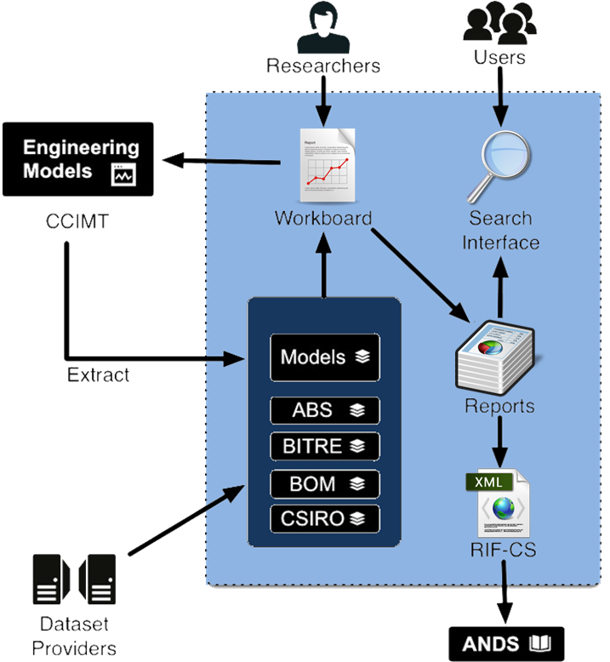
Figure 1: Climate Smart Seaports General architecture diagram
Researchers can use the application to create reports and add data originating from various sources. After gathering the pieces of data they need, researchers can then create reports and publish them on the CSS portal to make them accessible and searchable by all.

Workflow Changes
This section aims to describe the workflow of the application from a user point of view. It highlights the changes in added to the workflow compared to the first step of the project.
There used to be 4 main steps for the creation of a report: creation stage, data addition stage, analysis stage and publication stage.
We now have a simplified workflow, with only 2 steps: creation stage and edition stage. The creation stage hasn’t changed, but the edition stage encapsulates the data addition stage and analysis stage. A refined user interface provides a single step allowing performing all the actions that were available before in two steps. That solves the issue of not being able to “go back” and add or change some data while in the analysis stage. This critical issue was raised in a workshop at the end of the previous project.

Report Creation
Once logged in, the user the first lands on the list of his Reports (note that the terms of “Workboard” and “User Story” have disappeared). The user can either click to edit one of his existing reports, or create a new report.
The “Report Creation” page consists in setting the name, scope and purpose of the report that is going to be created. Clicking on “Create” on that page will create a new empty report, and go to the “Report Edition” page.
An extra option has been added, which enables the users to select “Include categories header” to include pre-defined headers within each category of the report (see section 1.4 for more details).

Report Edition
The “Report Edition” page is very similar to the former “Workboard” page.
Tabs are grouping elements into categories, and a last summary tab shows the elements of all categories. The user can add text and upload custom files to any category, which wasn’t possible before. From a developer point of view, note that it is now possible to link a data source to several categories, in order to make it appear in several tabs.
Figure 3: Report edition
The texts elements used to be added and edited only in the analysis stage, and have now been brought in the single “Report Edition” stage.
The re-ordering of element has also been moved to the “Report Edition” step (see section 1.3 for details).

Data Element Addition
Adding a data element brings a form that allows selecting a data source for it, and shows the parameters and options that are defined by the selected data source.
It also let the user select the initial display type for the element among those allowed for this data source. This can be changed later by selecting a different display type for the element.
Figure 4: Data Element addition form
Each element addition form (text, file or data element) has a field to define the original position of the element in the report. This can be modified later by re-ordering elements.

Summary tab
The Summary tab displays the elements of all categories together, giving an idea of the global organization of the report.

Figure 4: Summary tab of the report edition.

There is still the possibility to decide to exclude some elements that were added without deleting them completely from the report. Excluded elements will appear greyed in the “Report Edition”, and not appear at all in the preview and publications. It is possible to re-include excluded elements later.
At any time, the user can preview the report to see how the report looks like in a separate window.

Publication
Another major change in the workflow is the publication of reports.
Before, there was a single Workboard at a time per user, and several Reports (in the Analysis stage). Each Report could be published once, which meant it was locked to prevent further edition, and it was becoming public on the Seaports portal and on the ANDS data commons.
In this new project, there is no more workboard. The user only works on creating and editing reports. There can be any number of Reports edited at the same time. The main difference is that “publishing” a report doesn’t lock it: it creates a snapshot of the current state of the report, and makes that version public on the Seaports portal for other users to see. However, it keeps the original report and allows further editing.
That makes it a lot easier to create different versions of similar reports without having to start all over again every time.

User Interface Changes
Most of the user interface remains the same, and most of the user interface changes have been mentioned as part of the new workflow description. There are however several things that have changed or have been added with the goal of improving user experience and the flexibility of the final reports display.

USAID Logo
The ANDS logo of the Seaports project was replaced by the USAID logo, financing the Seaports Pacific project. It appears at the bottom right of every page of the tool, and links to: http://www.usaid.gov/

Regions Map Update
The map of Australia available on the report creation page was replaced by a map of the South Pacific area (new map shown below). The two regions available are Papua New Guinea and Fiji.
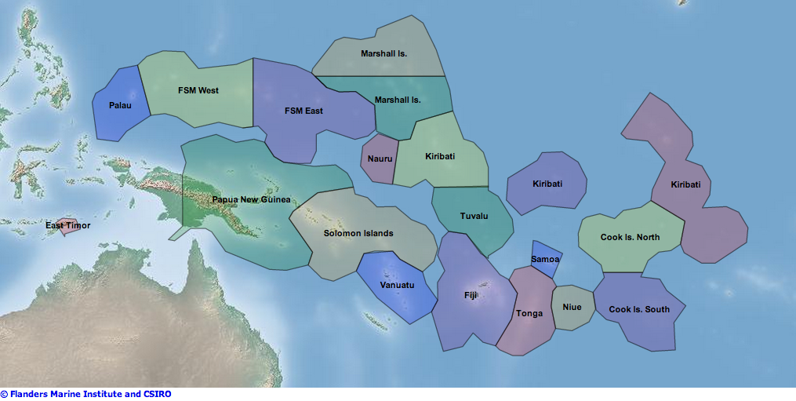
The copyright text attached to this map picture is as follows:
The Flanders Marine Institute manages Marine Regions, but is aware that it is not complete and undoubtedly contains errors. The Flanders Marine Institute cannot be made responsible for any errors or misuse of data contained in this register. Comments from our users are more than welcome, so if you come across any error or incomplete information or you are willing to contribute to this initiative please contact us.
The data is provided 'as is', and no warranty express, implied or otherwise is offered as to the data's accuracy. The developers do not imply any opinion concerning the legal status of any country, territory or area, or concerning the delimitation of its frontiers or boundaries. The data can be used for educational, scientific or research purposes but should not be used for legal, commercial/economical (exploration of natural resources) or navigational purposes.
Anyone can download this data but it is for the sole use of the organisation or individual downloading the data. The geodata may not be redistributed without the permission of the Flanders Marine Institute (VLIZ). The geodata may be used in a Value-Added Software Application (like webservices), on condition that the Flanders Marine Institute is acknowledged as the source of the data. Redistribution rights are granted for hard-copy renditions or static, electronic map images (e.g. jpeg, gif, etc.) that are plotted, printed or publicly displayed with reference to the Flanders Marine Institute. For redistribution rights of derived products, please contact us. You can contact us atinfo@marineregions.org
The database can be cited as follows: Claus S., De Hauwere N., Vanhoorne B., Hernandez F., Mees J. (Flanders Marine Institute) (2014). Marineregions.org. Accessed at http://www.marineregions.org on 2014-02-24.
The map has been adjusted by the CSIRO to better fit the needs of the The Pacific Climate Change Science Program Climate Futures http://www.pacificclimatefutures.net/main/

User-defined re-ordering within categories
The re-ordering of elements in the report used to be achieved into the second step of the workflow, where all the elements were present. This used to allow the user to arbitrarily reorder elements in the report.
It has been decided that the reports will now be structured by the categories, creating the main sections in the final reports. The user can still reorder elements within each category tab, but elements of the first section will always appear before elements of the second section, etc.

Pre-defined sections headers
A new check box appears at the bottom of the report creation form. This additional field allows specifying whether some default headings should be automatically added in each category tab.
When checked, the report is filled with one preformatted text element in each category stating the title of the category. The final report therefore contains headings showing the categories.
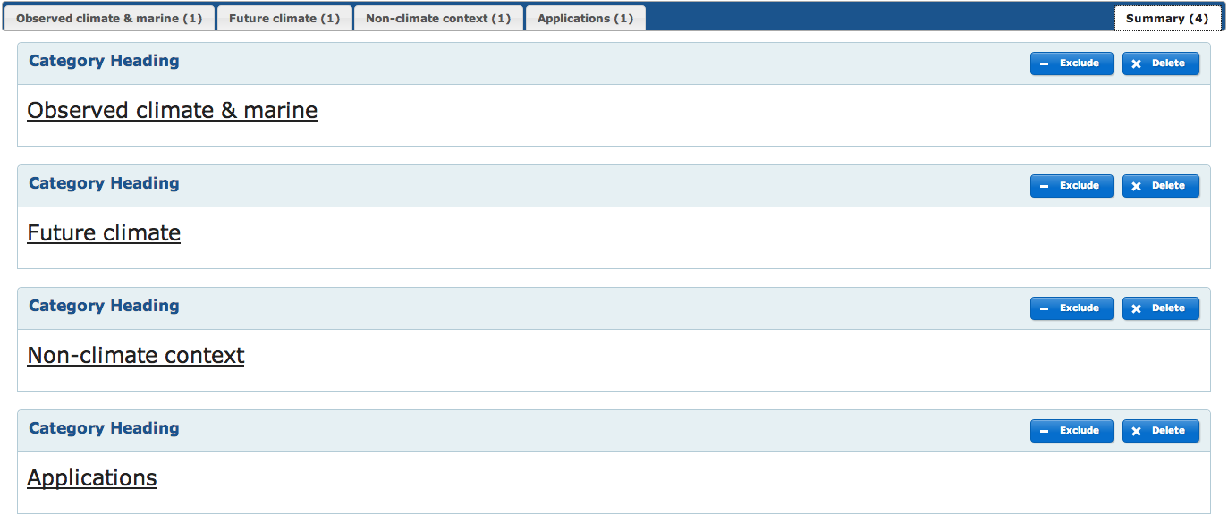
There are 2 side effects of this change
- the little green ‘checked’ icon signaling whether each category tab contained at least 1 element or not lost it’s meaning. It has been replaced by the number of elements present in the category instead. The summary tab contains the total number of elements in the report.
- The explanation text that used to appear on empty categories after creation of a new report can’t be displayed when the categories tabs are pre-filled with headings. To solve that issue, a message appears under the action buttons within each tab: when hovering this message with the mouse, it reveals the full explanation text.

New action buttons
The actions buttons have evolved to support the new workflow described above as well as a set of new features.

Report level
- The “Save Order” button allows saving the order of the elements within the current category tab. It is grey by default, and becomes blue when the user reorders elements using drag and drop.
- The “Delete Report” button deletes permanently the whole report. However, it doesn’t delete the publications based on it.
- The “Preview the Report” button opens a new window showing what the final report would look like if published at this instant.
- The “Publish Report” button creates a publication based on the current version of the report. The report can then be further edited or deleted without impacting the publication’s “snapshot”.

Category level

There are now 3 different buttons to add elements to a category: add data, add text, and add file.
- The “Add Data” button opens the “New Element” modal window, which allows the user selecting data provided by the tool or completing forms
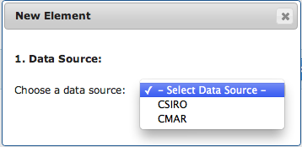
- The “Add Text” button opens the “New Text” modal window, which allows the user entering custom text. It is the same for each category. The only difference is the content of the dropdown list allowing choosing the position of the new text element among the other elements of the category.
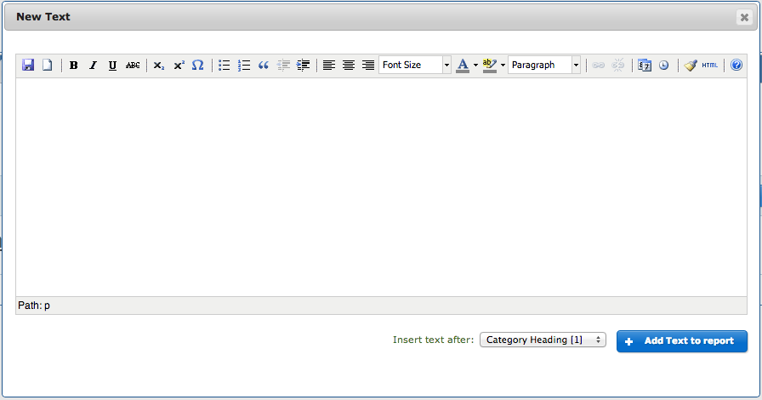

- The “Add File” button opens the “New File” modal window, which allow the user to upload custom text, images, or CSV files. It is the same for each category. The only difference is the content of the dropdown list allowing choosing the position of the new file element among the other elements of the category.
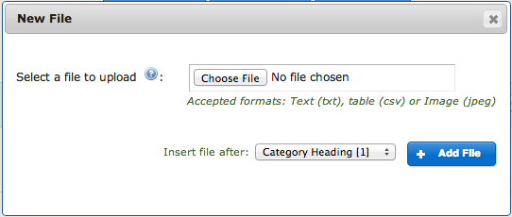

Element level
Two buttons are still the same as in the previous version of the tool: the button to delete an element and the button to include or exclude an element from the publications without removing it completely from the report. Below are captures of a data element
On data elements, a dropdown list highlights the current display type of the data element, and lists the other available display types (based on the available types for the data source). Changing the selection of that dropdown updates the display type of the data element.
On text elements, another action button is present, enabling to edit the content of the text:
A “Width” dropdown list provides an option between the default 100% option and a 50% option. This defines the width of the element in the final report. Selecting 100% lets the element take the full width of the report, and selecting 50% limits the width of the element to half of the report width. This allows having two 50% elements side by side in a report.

A “Page Break” check box allows specifying that a page break should be included after the element in the report publication view. A page break is displayed as a grey dashed line in the online view of the publication, and as an actual page break on the print version.
In the print version, some additional page breaks are automatically added by the application to avoid splitting an element.

Data model Refactoring
This section describes the changes performed on the Climate Smart Seaports data model in order to support the workflow and user interface changes described above.

Reports
Unlike the previous version of the project where there was a “Workboard” that could be transformed into a “User Story”, and then published as a “Report”. There could be one single “Workboard” at a time, and several “User Stories” that were either private, or public ad published.
In this new version there is only one single “Report” entity for everything that is private. There can be several Reports created and edited at the same time. When the user selects to publish a “Report”, it creates a report publication, which is essentially a snapshot of the current state of the “Report, serialized into a field of the “ReportPublication” entity.
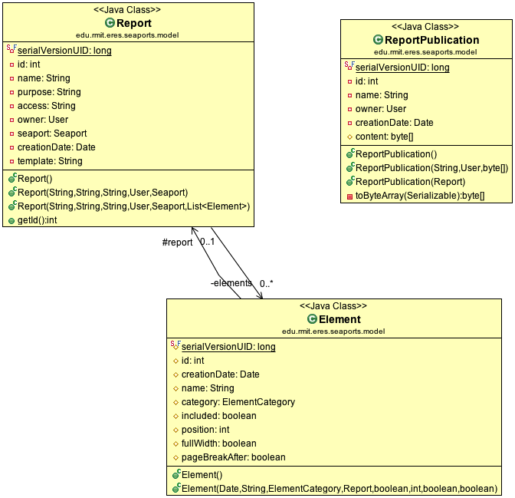
This enables managing separately the reports and the publications. If a publication is deleted, the snapshot of the report that it contains is deleted as well, but not the original report since the publication is completely decoupled from it.
From a user point of view, it can be used to publish different versions of a same report, or make it evolve over time.

Elements
Elements are composing a report. There are 2 types of elements: Input Element and Data Elements, both inheriting from the same Element class.

Input Element
Input Elements are text elements directly typed into the tool by the user, and uploaded files (pictures, texts, tab-separated value documents). These haven’t changed in comparison to the previous version of the project.

Data Elements
Data Elements are elements that refer to a data source to get their data. The Behavior of Data Elements has changed compared to the previous version of the project in that they hold a reference to the Data Source entity in the database, and a list of options defining the user selection for each of the data source parameters (see section 2.4 about Data Sources).

Categories
Element categories have been added as database entities rather than only existing in the source code. That provides a high flexibility regarding the number, order and name of the categories: if a new category is created in the database, it is automatically displayed in the report edition as a tab.
Data sources can be linked to one or more categories. They will be listed in these categories, letting the user add elements from this source to the category. For example, the “Vulnerability Assessment” data source is linked to both “Observed Climate” and “Applications”.
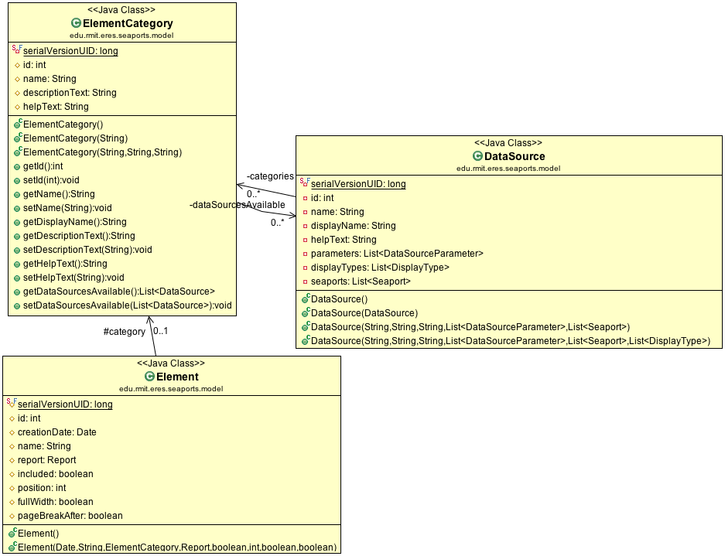

Data sources
Data sources contain a list of parameters, allowing users to customize the data from the data source for their reports. Each parameter contains a list of the possible options to choose from. When creating a new data source, a developer also has to create the parameters and options available for it in the database. Based on this information, the application will automatically generate the form to add data elements from this data source.
Each data source entity belongs to one or more category. They also contain a list of seaports for which it is available.
All data source classes must inherit from the abstract class “DataSource”, implementing the interface “IDataSource”:
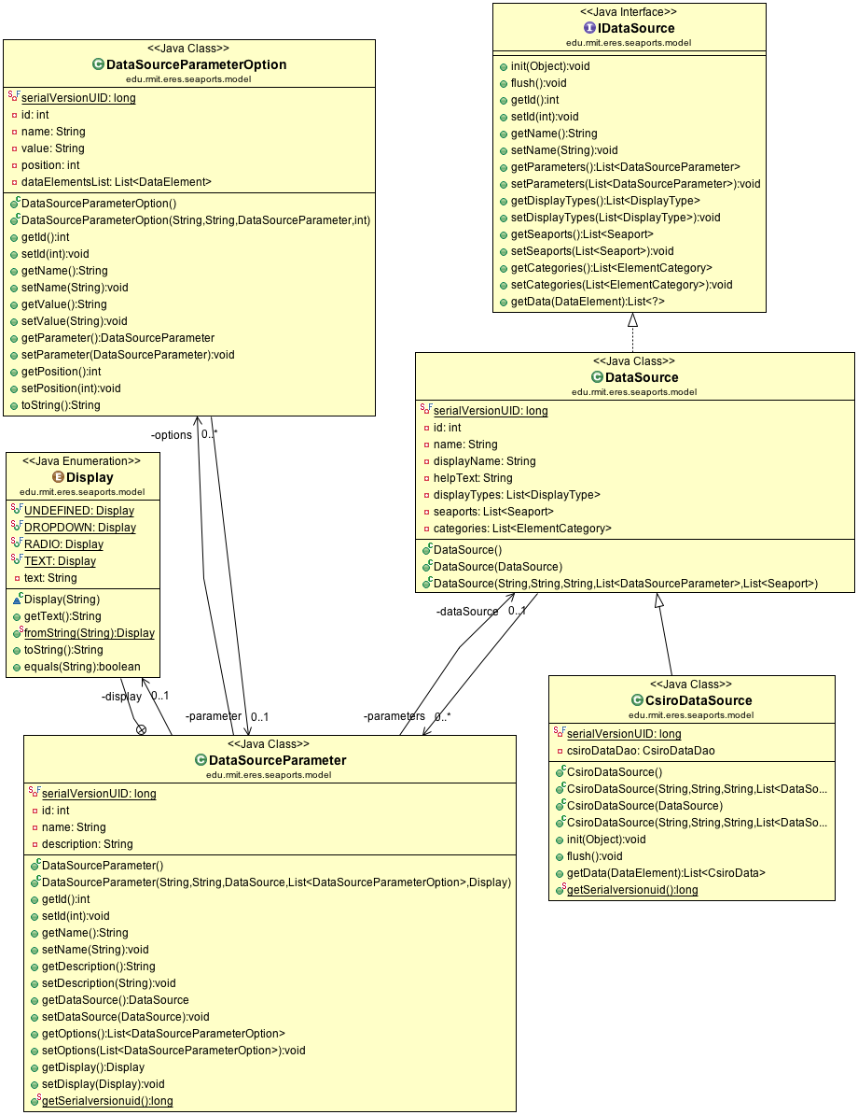

Display types
Display types define the way the data contained in a Data Element is displayed.
Each data source contains a list of available display types, for which the data they provide can be displayed. Users can select among available display types for each element they create using this data source.
The display types currently existing are: Text, Graph, Table, Map and Picture. However, the “Map” type isn’t currently available data source.
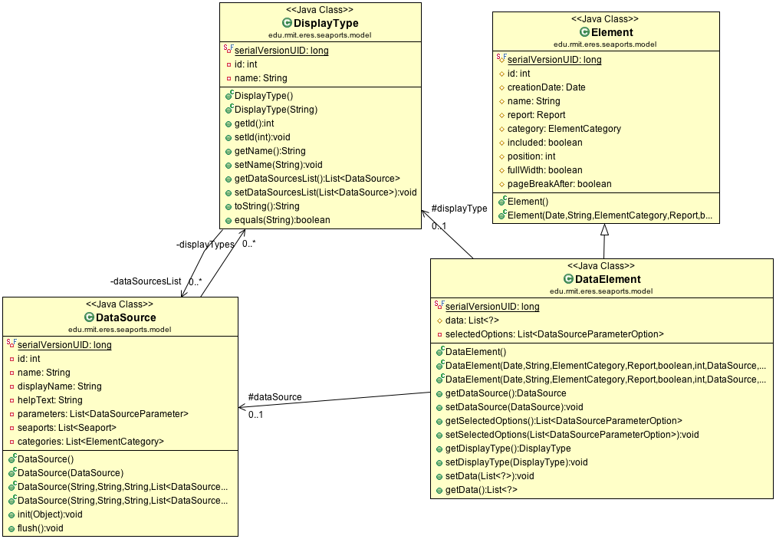

New Data Sources

Data Sources Description
Data sources description, in which categories, data sources & display types association.

The following table is a list of existing data sources per category:

Observed Climate & Marine | Future Climate & Marine | Non-climate Context | Applications
- Observed Trends  - Observed Extreme  - Current Risk Assessment  - Vulnerability Assessment | - Future Trends  - Future Extreme  - Future Risk Assessment | - Demographics Data | - Vulnerability Assessment

Instructions about how to create new Data Sources can be found in the document “Creating New Datasources - Developer Documentation - Seaports Pacific”.

Data Retrieval Process
When a report needs to be displayed, it is retrieved from the database, including the list of elements it contains. Before passing on to the Views, the ReportController calls the method “Report prepareReportData(Report)” which iterates over the elements of the report and call “Element prepareElementData(Element)” for each of them.
This method dynamically instantiates the correct DataSource class, eventually get it ready (in most of the cases, by passing a Data Access Object to it).
It then calls the “List<?> getData(Element)” method from the DataSource instance which actually retrieves the data for that element.
After the getData call, the flush method is called to get the DataSource instance to perform any cleanup if required. The data element filled with the data retrieved is then returned.
Following is the full source code of this key function, in the file ReportController.java:
private Element prepareElementData(Element element) {
if (element.getClass().equals(InputElement.class)) {
InputElement ie = ((InputElement)element); ie.generateStringContent();
return ie;
}
else if (element.getClass().equals(DataElement.class)) {
DataElement de = ((DataElement)element);

try {
// Instantiate the data source of the sub-type specified by the data source name
String className = "edu.rmit.eres.seaports.model." + WordUtils.capitalize(de.getDataSource().getName()) + "DataSource";
Constructor<?> constructor = Class.forName(className).getDeclaredConstructor(DataSource.class);
constructor.setAccessible(true);

// Cast to the correct specific data source type
Class<? extends DataSource> dataSourceClass = Class.forName(className).asSubclass(DataSource.class);
DataSource ds = dataSourceClass.cast(constructor.newInstance(new Object[] { de.getDataSource() }));

// Initiate the data source with an Autowired DAO if needed
if (ds instanceof ObservedTrendDataSource)
ds.init(observedTrendDataDao);
if (ds instanceof ObservedExtremeDataSource || ds instanceof FutureExtremeDataSource)
ds.init(extremeDataDao);
if (ds instanceof FutureTrendDataSource)
ds.init(futureTrendDataDao);

// Retrieves the data and set the element's data field
try {
List<?> data = ds.getData(de);
de.setData(data);
}
catch (NoResultException e) {
e.printStackTrace();
}

// Flushes the datasource (dispose of resources not needed such as DAOs)
ds.flush();
return de;
}
catch (NoSuchMethodException | SecurityException | ClassNotFoundException | InstantiationException | IllegalAccessException | IllegalArgumentException | InvocationTargetException e) {
e.printStackTrace();
}
}
return element;
}
After the element list is fully prepared and all data is retrieved, the Views are used to display the elements. The Views still work as they used to in the previous version of the project, using Apache Tiles to select JSP files to be used.
Within a report, the “element.jsp” View is used, in which Input Element are simply displayed (either as a picture or just displaying the content into the page), and the Data Elements are dynamically included. The include call is based on the data source and the display type of the element:
Snippet of elements.jsp:
<jsp:include page="dataElements/${formattedDataSourceName}/${element.displayType}.jsp" />
For example, if the element’s data source is “Observed Trend” and the chosen display type is “Picture”, the included file would be “dataElements/ObservedTrend/Picture.jsp”.
When creating a new Data Source, a developer must make sure that:
- the correct folder is created for this Data Source in the data element folder (name of the Data Source with camel case).
- each of the available display types specified for this Data Source in the database has a corresponding JSP file existing in that folder.
More information about how to create new Data Sources is available in the document: “Creating New Datasources - Developer Documentation - Seaports Pacific”.

